**Church Event Application with Document Request System**

A System Proposal presented to the

Faculty of the College of Computer and Information Sciences,

Polytechnic University of the Philippines, Sta. Mesa, Manila

In partial fulfillment for the degree

Bachelor of Science in Information Technology

Del Rosario, Eldrin Rei P.

Ebrada, Jonalyn Fe D.

Macaya, Joshua Rae

Peñaverde, Norme Ann Joyce T.

***Proponents***

**August,2018**

# **Chapter 3 – Methodology**

* 1. **Requirements Analysis** 
     1. Requirements – Features Matrix

|  |  |  |  |  |
| --- | --- | --- | --- | --- |
| **Feature**  **Requirement** | **Event Application Module** | **Document Request Module** | **Notification and Full Calendar** | **Mailbox** |
| Online Transaction |  |  |  |  |
| Online Event Application/Document Request |  |  |  |  |
| Online Submission of Requirements |  |  |  |  |
| Online Scheduling |  |  |  |  |
| Notification |  |  |  |  |
| Messaging |  |  |  |  |

* + 1. Use Case Diagram

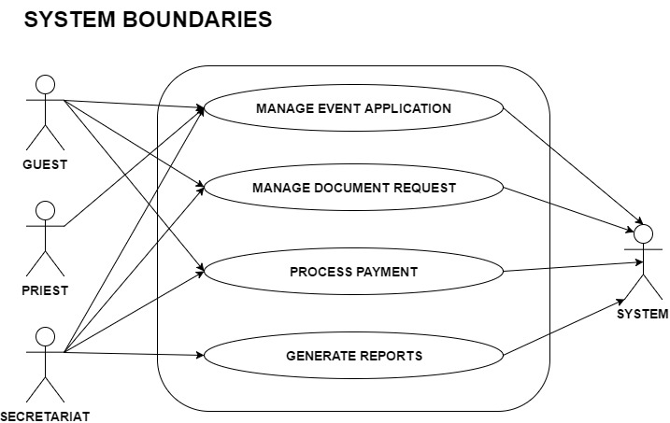

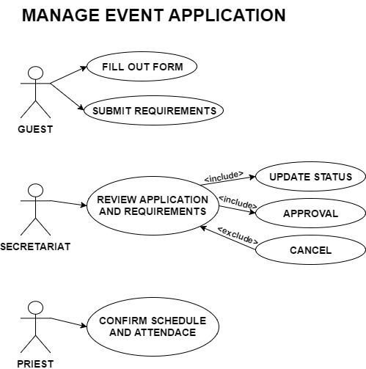

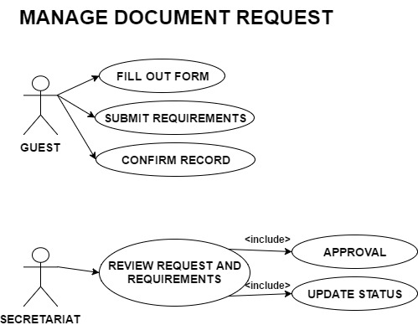

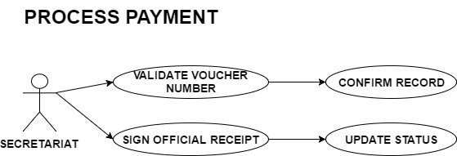

* + 1. Use Case Report

|  |  |
| --- | --- |
| **Use Case** | Manage Event Application |
| **Brief description** | This use case allows the guests apply for different sacramental services/events of the parish. |
| **Actors** | Guest, secretariat, priest |
| **Pre-conditions** | The guest has access to the system |
| **Basic Flow** | The system shows the landing page  The guest chooses which event he/she will apply for.  The guest fills out application forms and submit it  The guest submits their requirements  The secretariat reviews the application and requirements  The secretariat will either approve or disapprove the application based on the application details and the requirements.  The secretariat must update the application status of guest  The priest will confirm if they could attend the event, and confirm or change the tentative schedule. |
| **Post-conditions** | Notification will be sent to the guest if their application is approved. |

|  |  |
| --- | --- |
| **Use Case** | Manage Document Request |
| **Brief description** | This use case allows the guests request document |
| **Actors** | Guest, secretariat |
| **Pre-conditions** | The guest have access to the system  The guest must know the full name of the person in the certificate and the month and year the event was held. |
| **Basic Flow** | The system shows the landing page  The guest chooses the document he/she wants to request  The guest fills out the request form  The system will search for the record  The guest will confirm the record  The system, will generate the document  The secretariat reviews the request  The secretariat will approve or disapprove the request.  The secretariat will update the status of the document whether it is still requested or to be released.  The secretariat will release the document and update the document status to released. |
| **Post conditions** | After their document is requested, they must download their voucher and go directly to the office to get their original document. |

|  |  |
| --- | --- |
| **Use Case** | Process payment |
| **Brief description** | This use case is for processing the payment of the guest. |
| **Actors** | Secretariat |
| **Pre-conditions** | The guest has already applied for an event/ reserved a facility/ requested document  The secretariat has approved the application/request  The guest must have their voucher with them or must know their voucher number |
| **Basic Flow** | The guest will download the document.  The secretariat will validate the voucher and search fot the record  The secretariat will ask the guest if the record is correct and confirm it in the system.  The secretariat will collect the payment and sign the receipt  The secretariat will update the payment status |
| **Post-conditions** | The guest must receive official receipt |

* 1. **Design Specifications** 
     1. 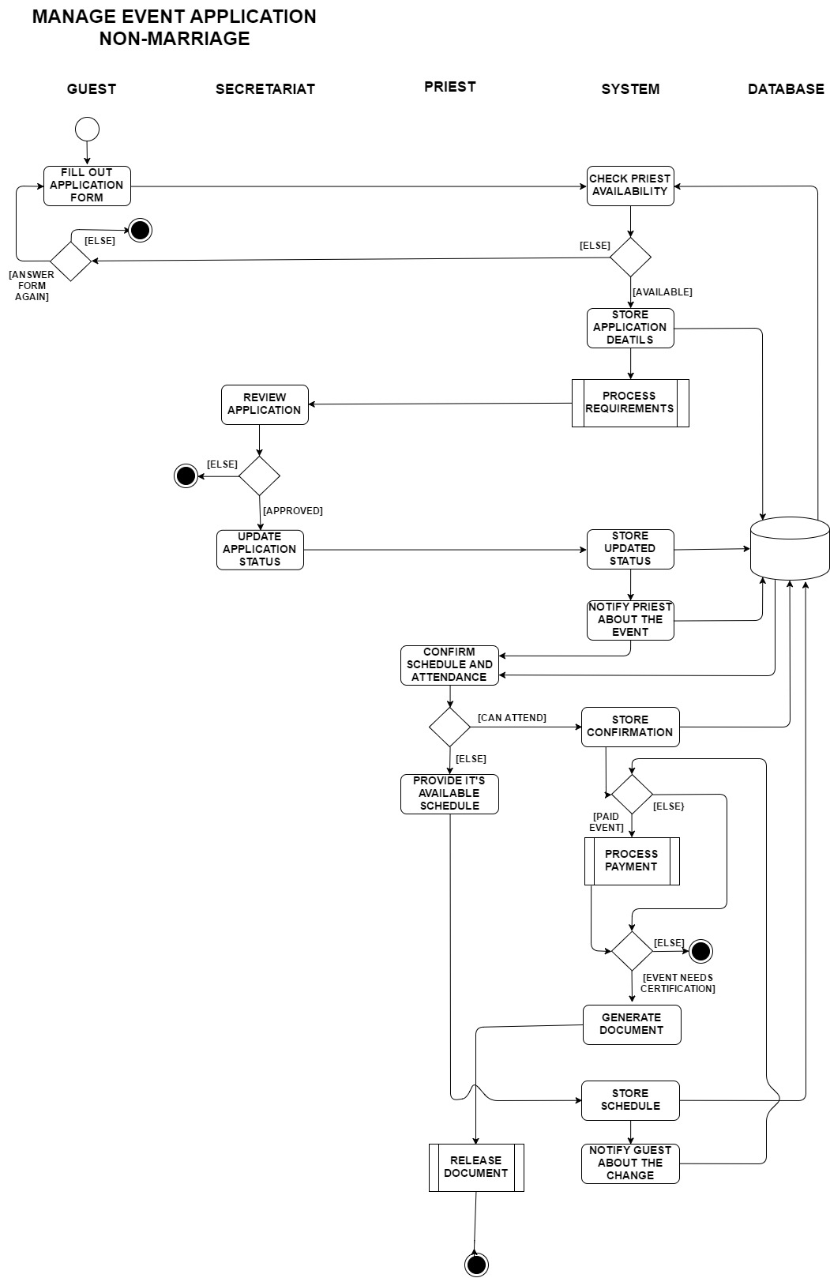Activity Diagram (per use case

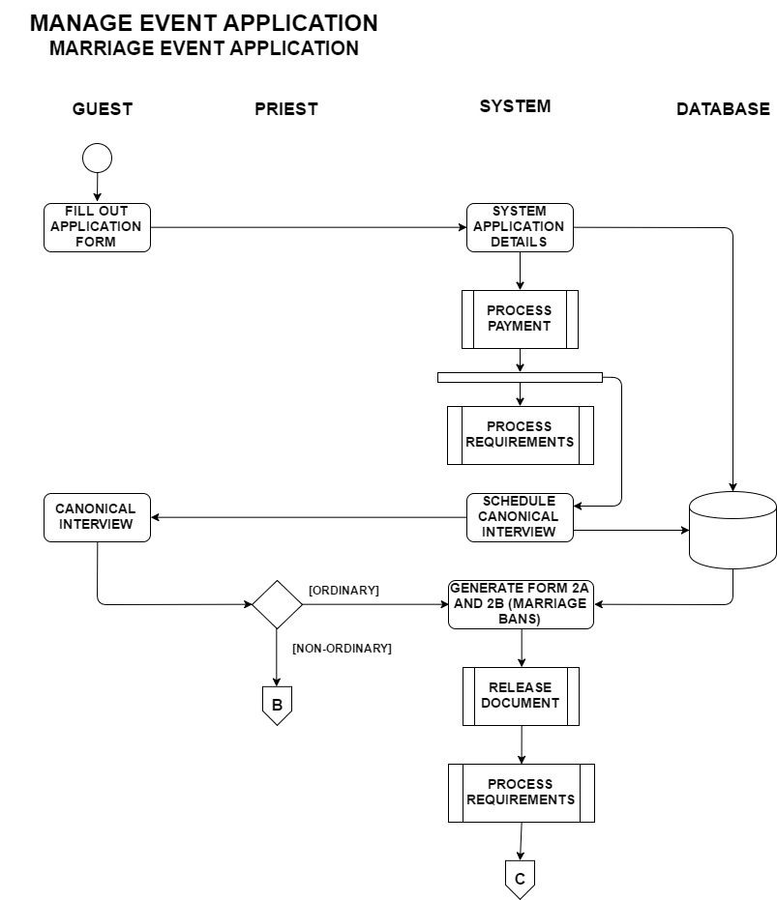

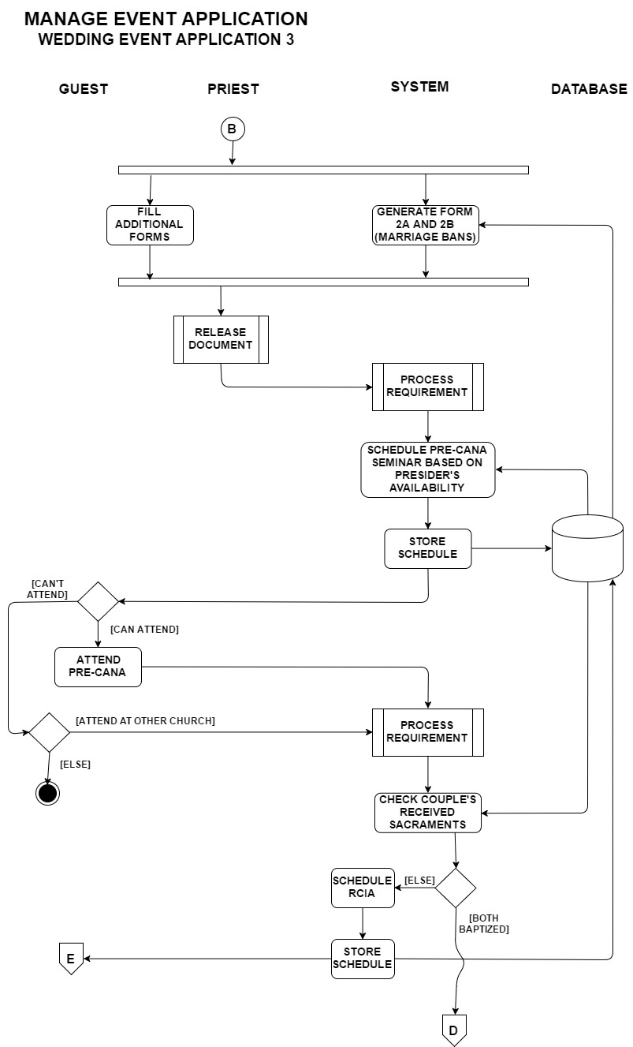

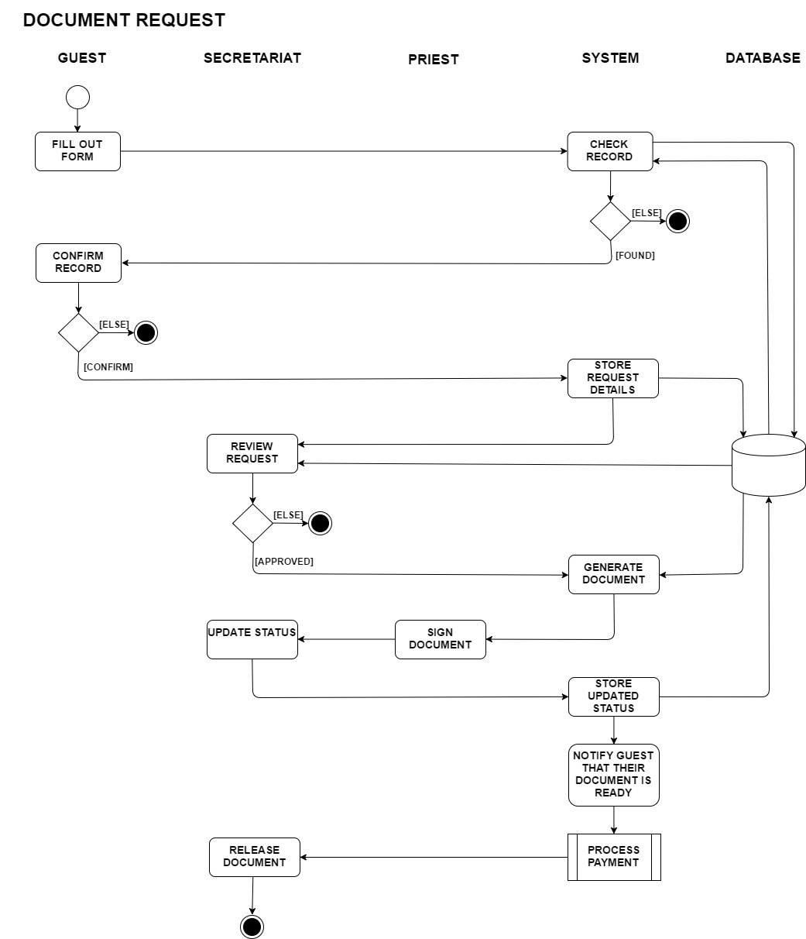

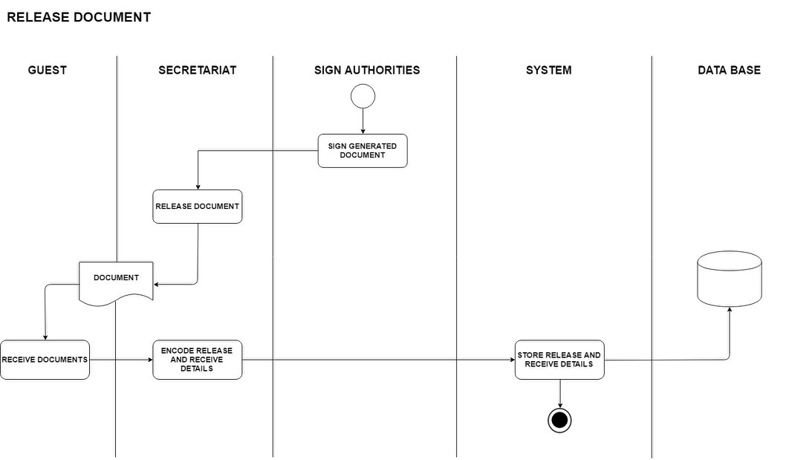

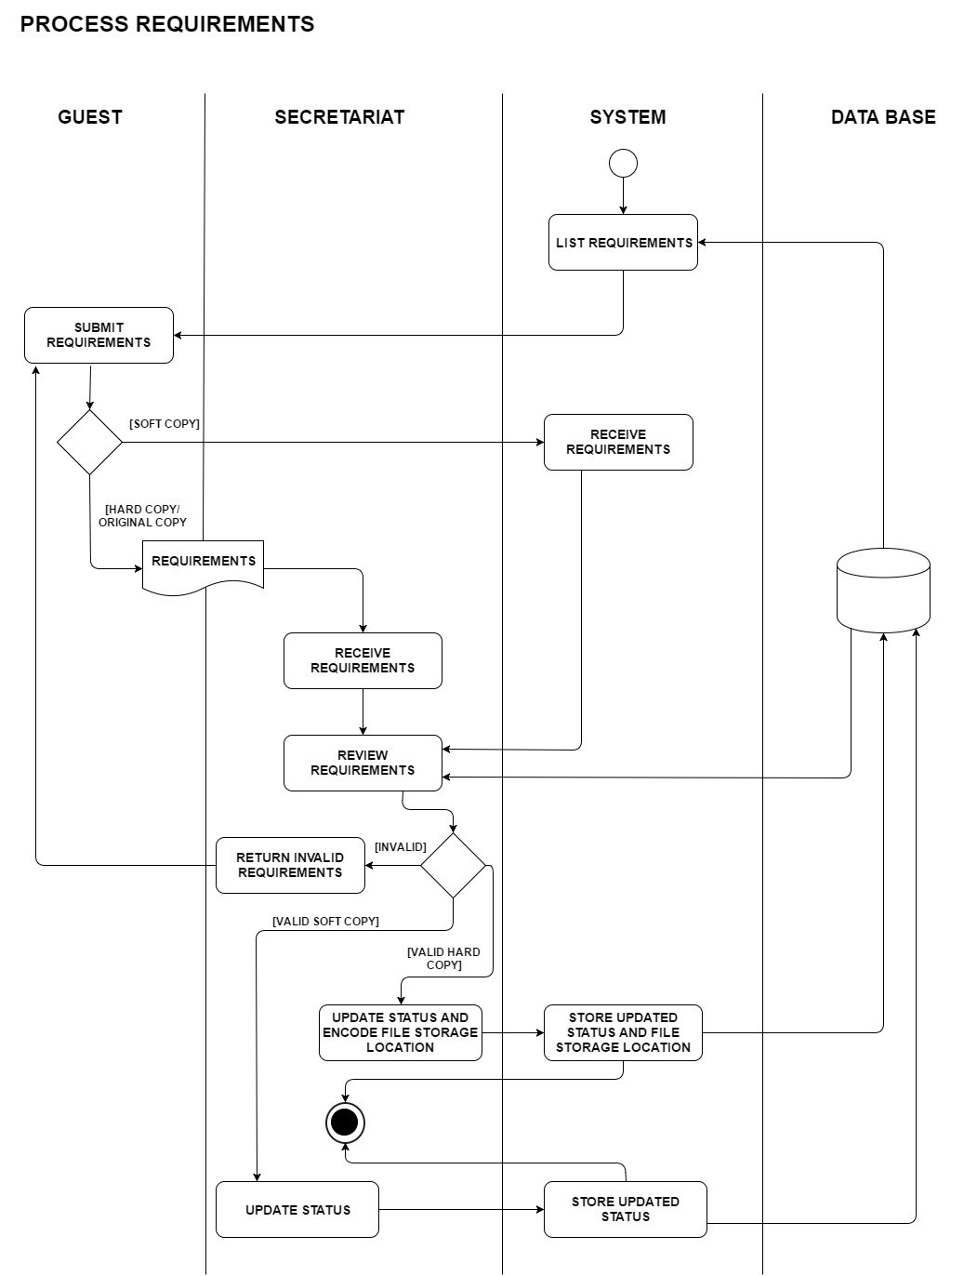

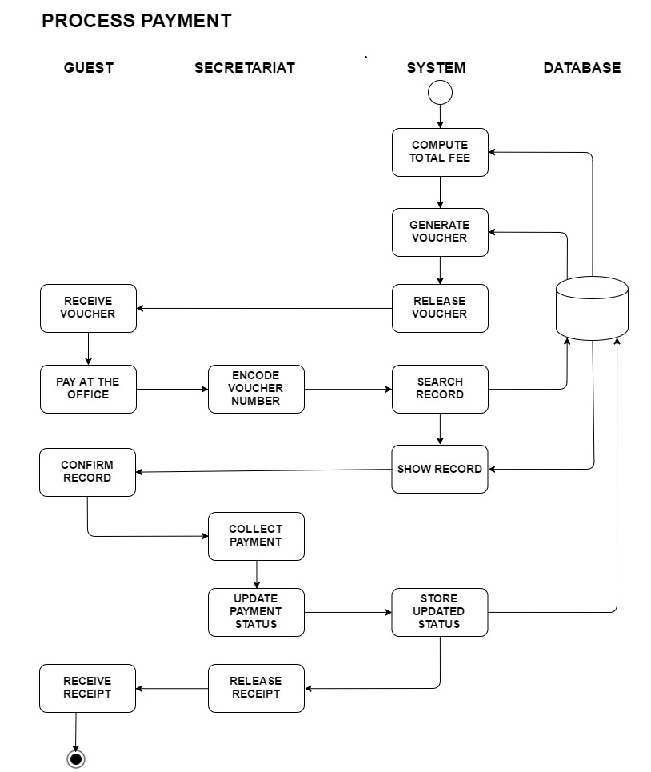

* + 1. GUI Design (screen shots)

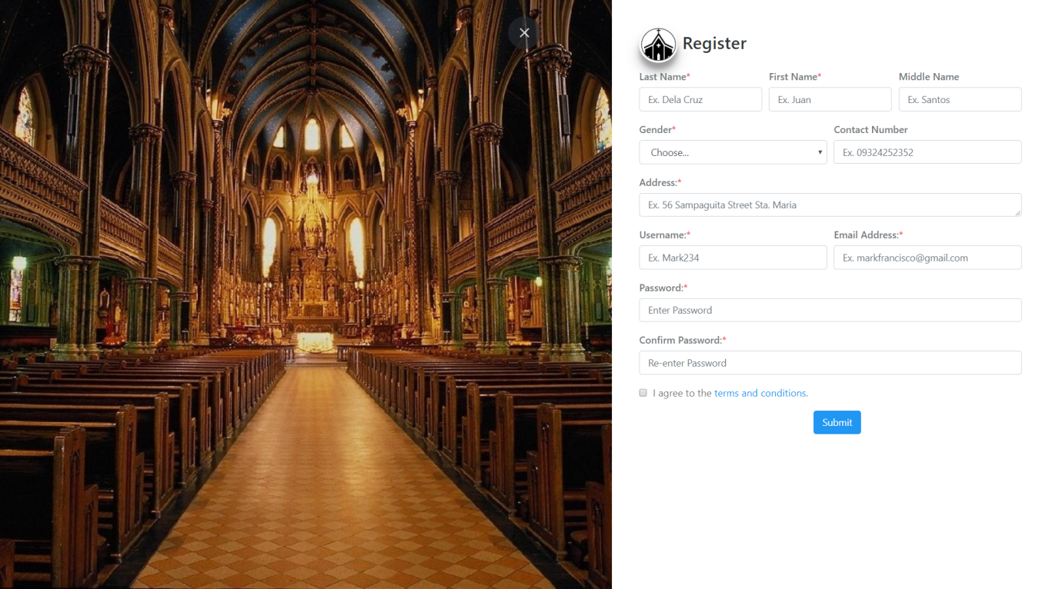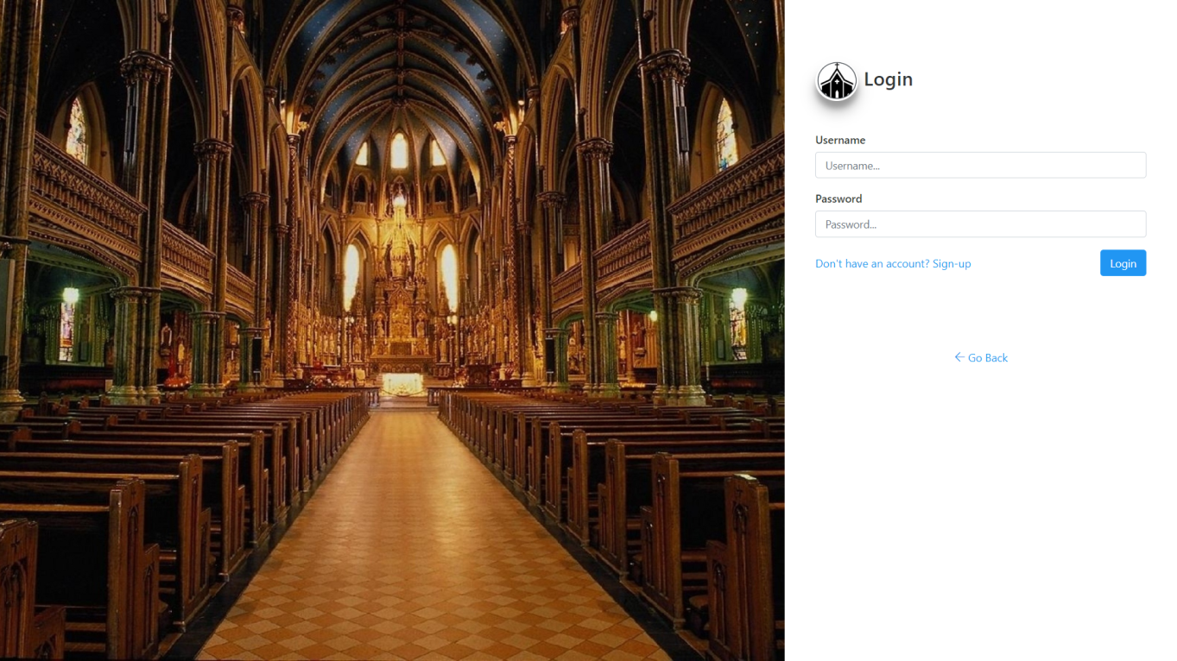SIGN-IN

SIGN-UP

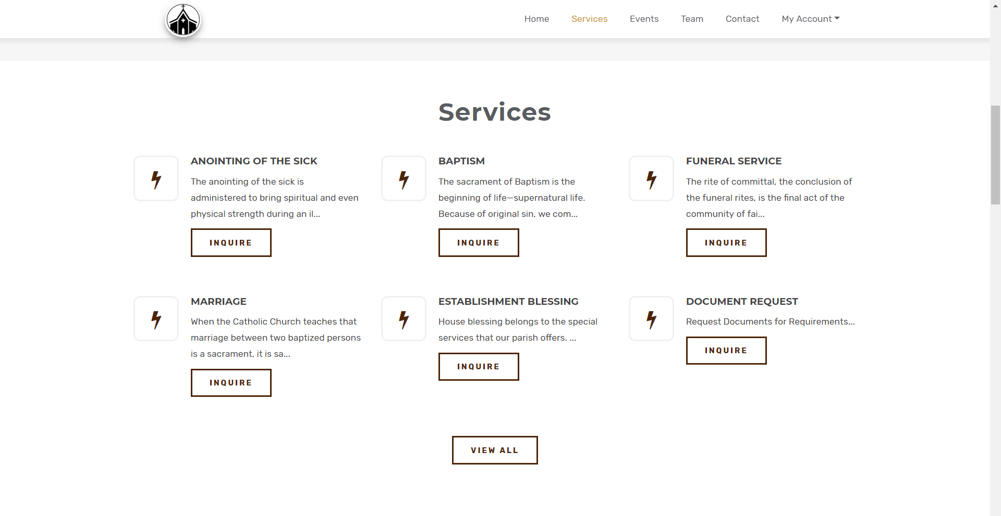SERVICES

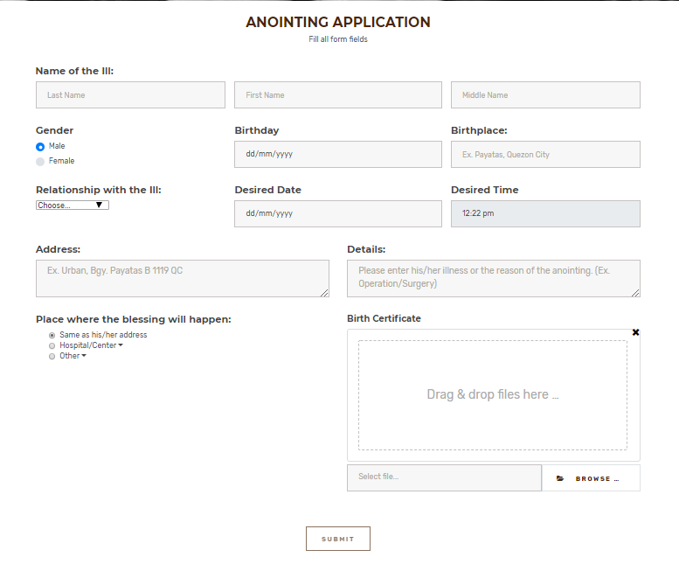

ANOINTING

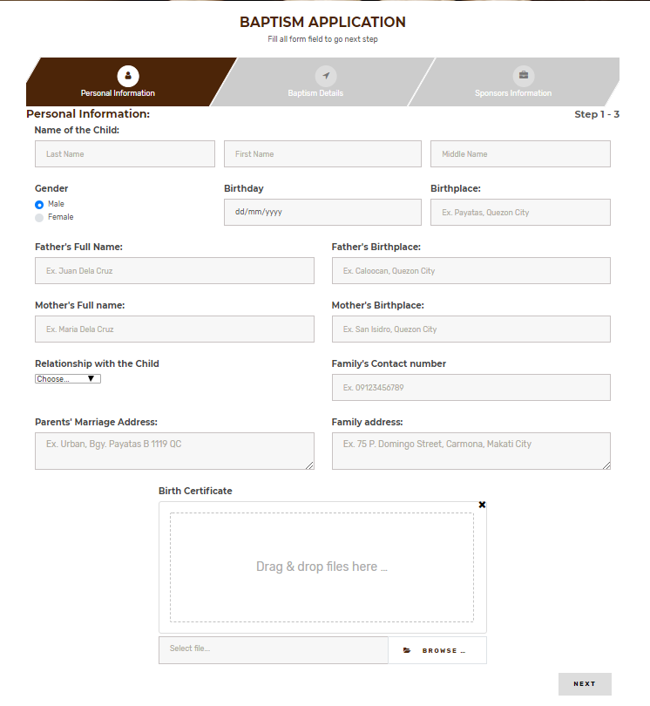

BAPTISM 1

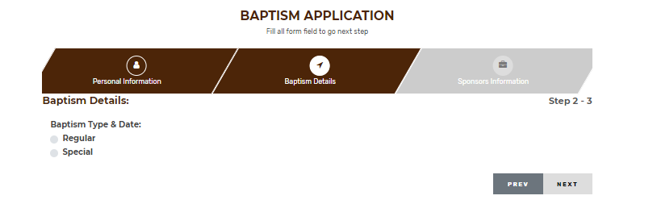

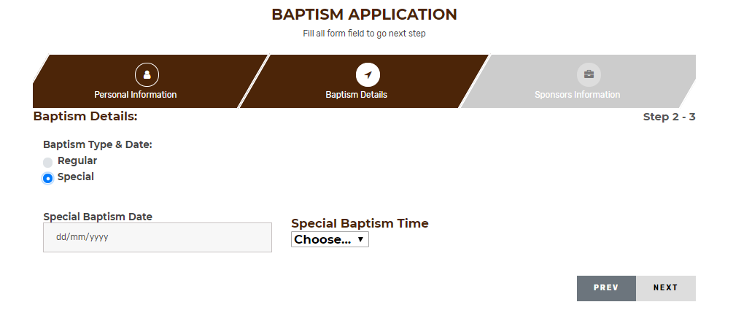BAPTISM2.1

BAPTISM 2.2

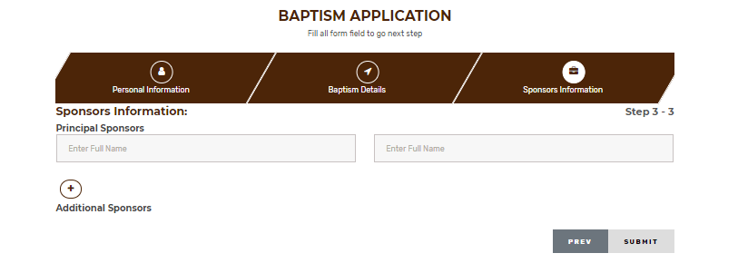BAPTISM3

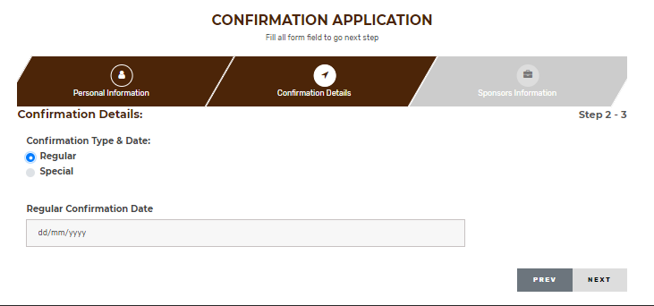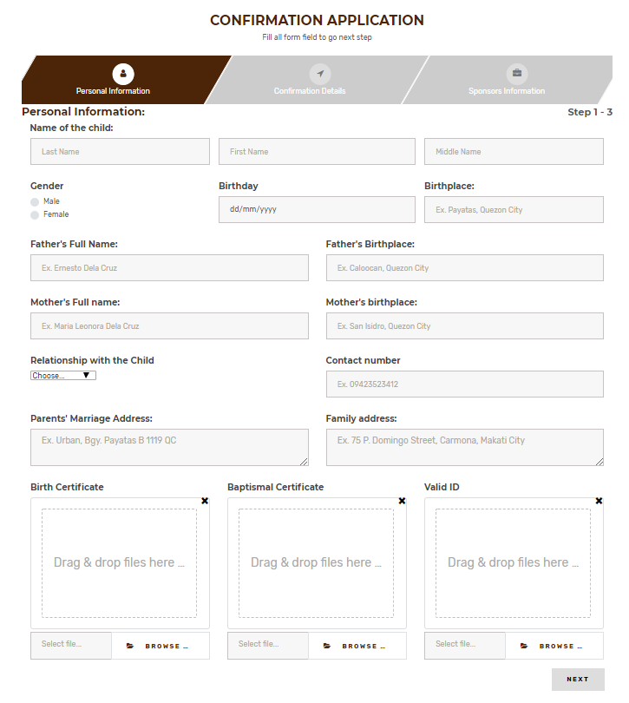CONFIRMATION 1

CONFIRMATION 2.1

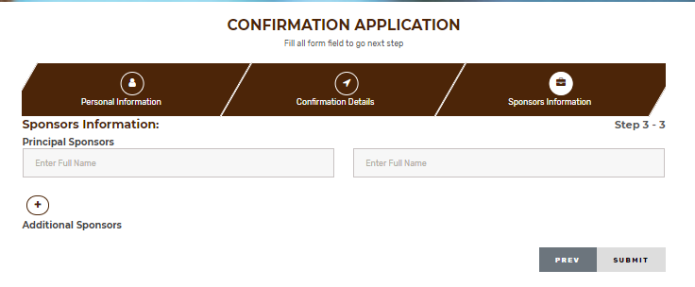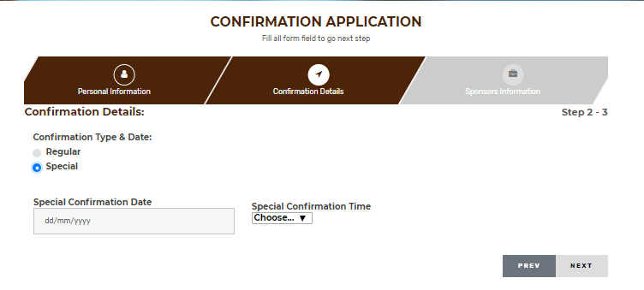CONFIRMATION 2.2

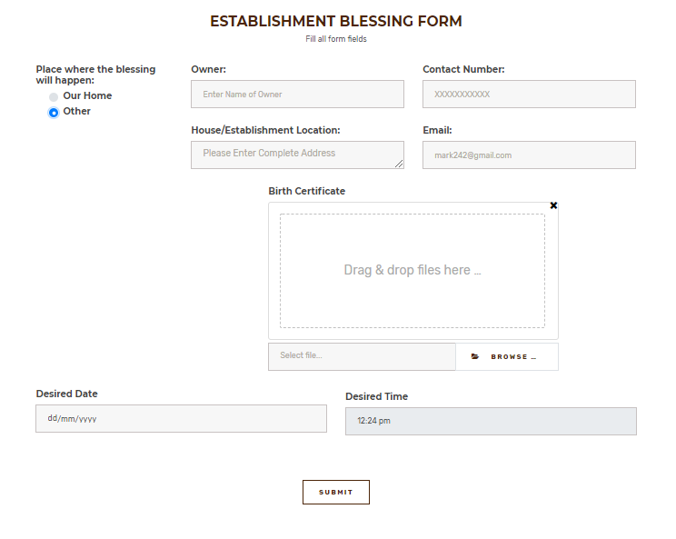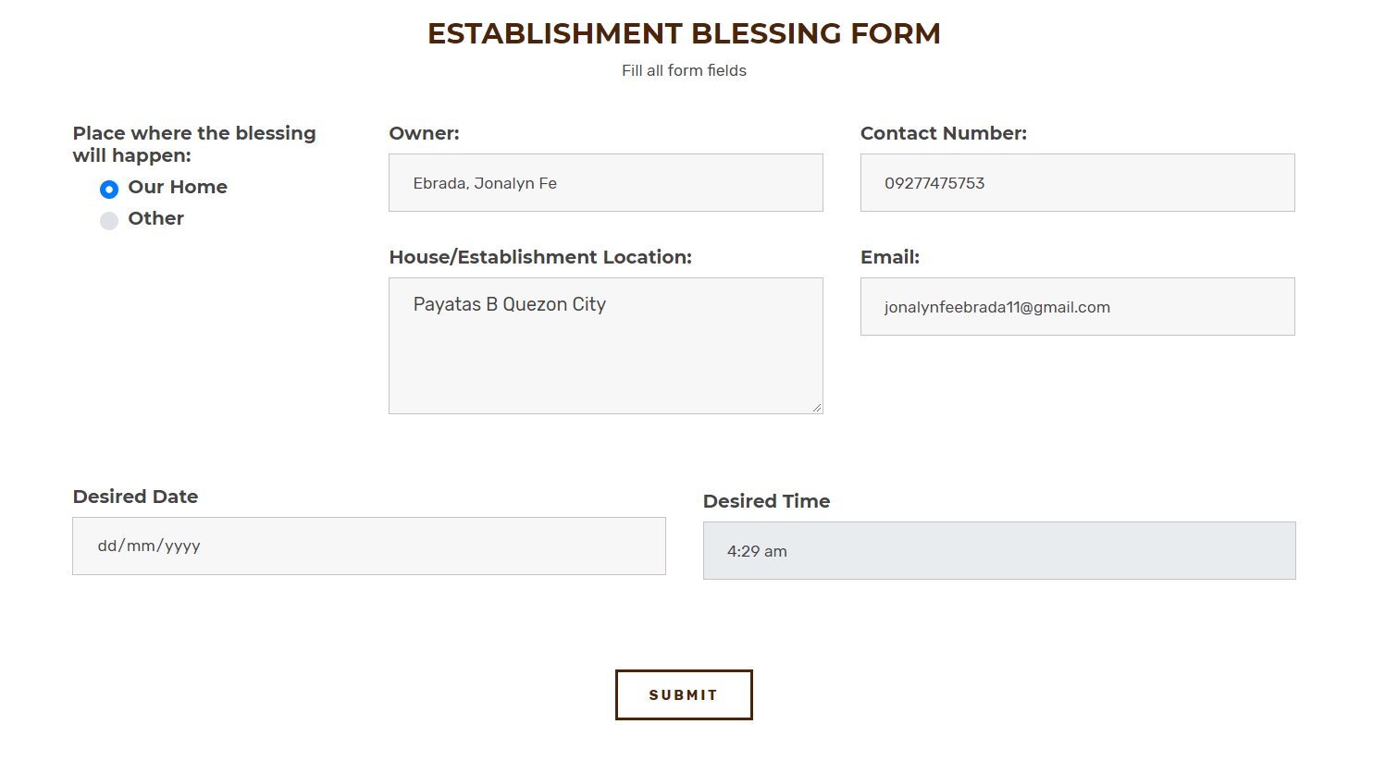Establishment blessing 1

Establishment blessing 2

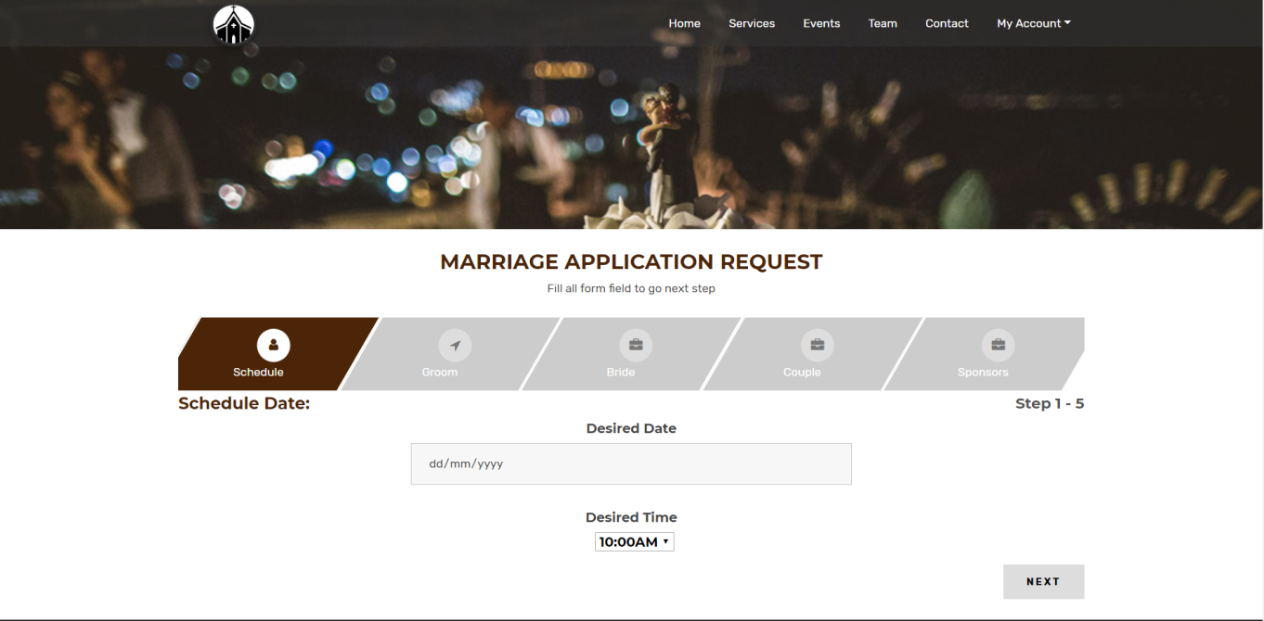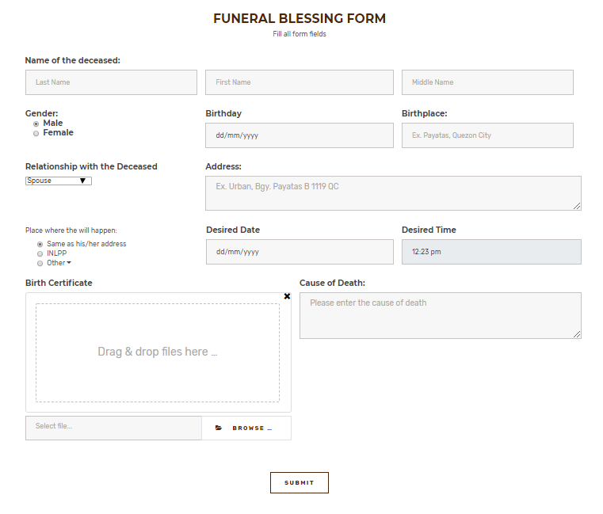Funeral Blessing

Marriage (Reservation)

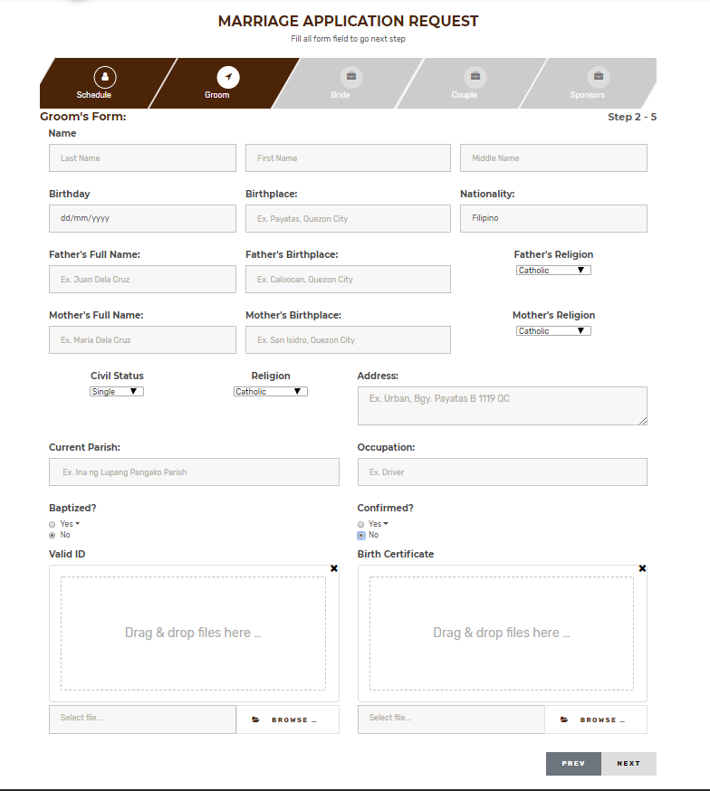Marriage Groom Form

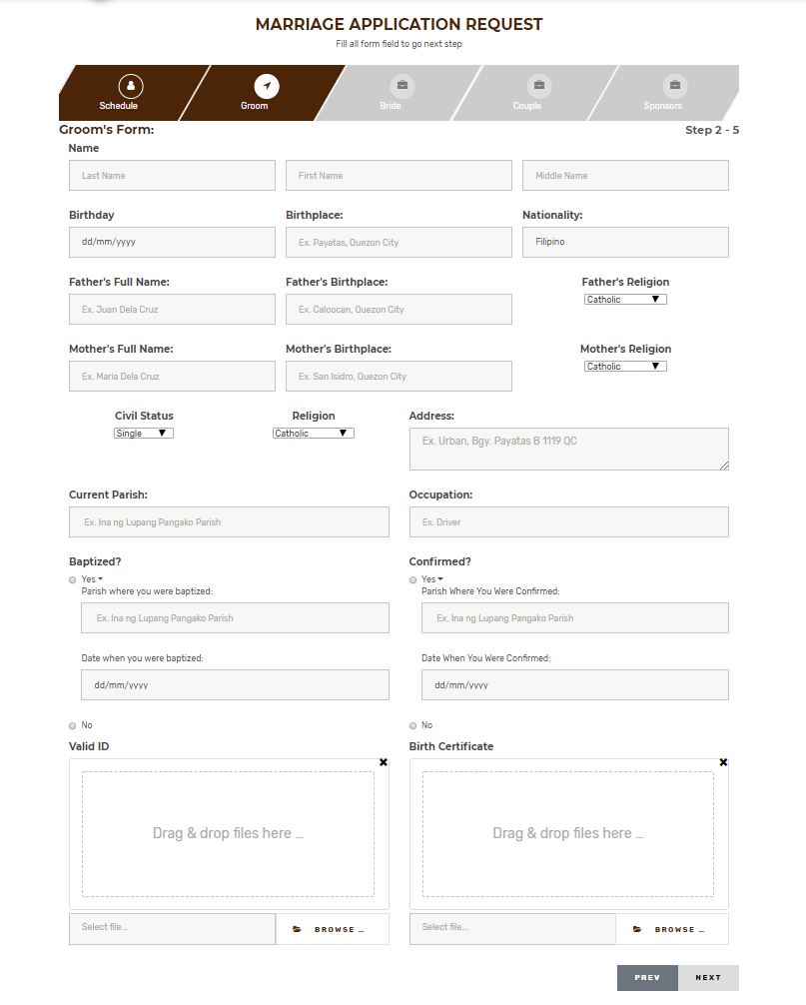

Marriage Groom Form 2

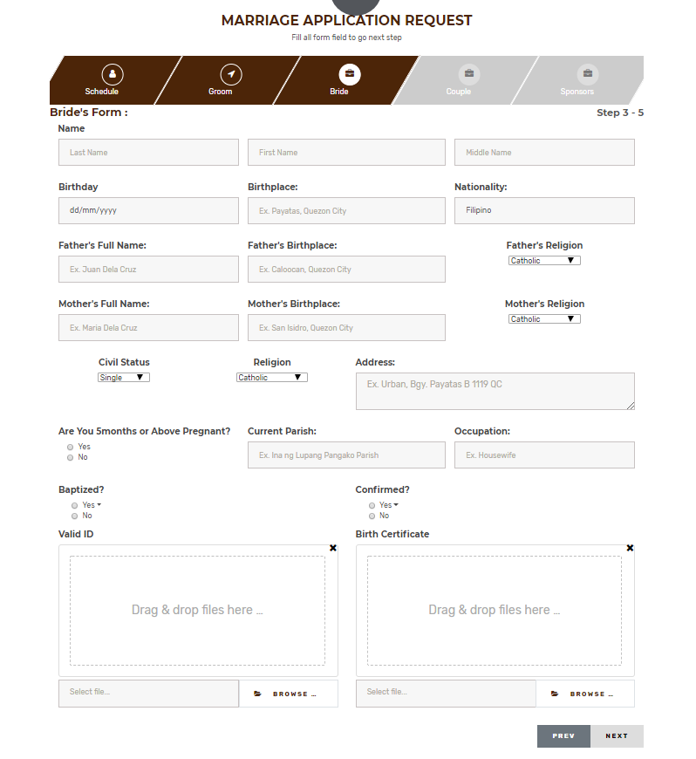

Marriage Bride form

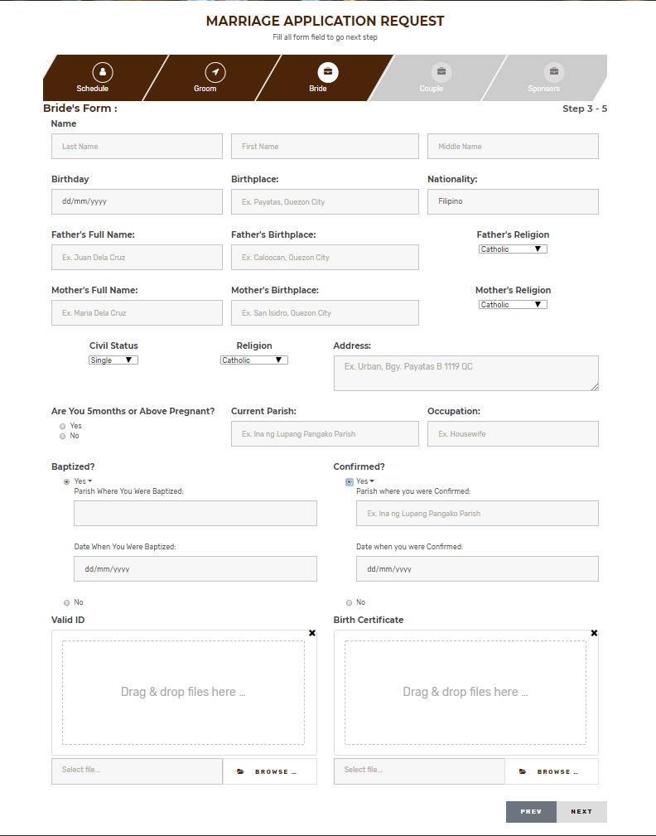

Marriage Bride form 2

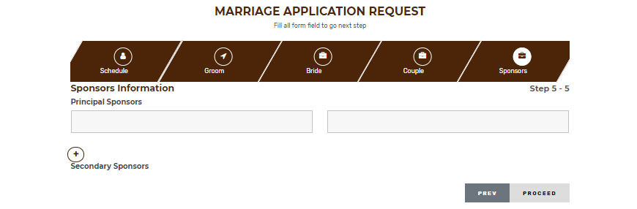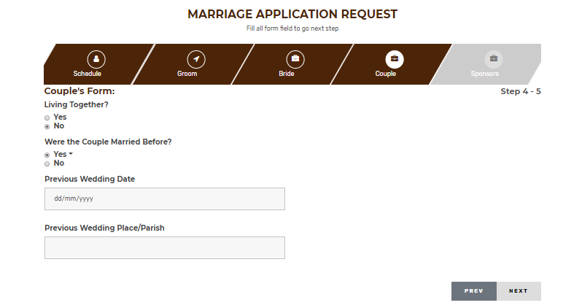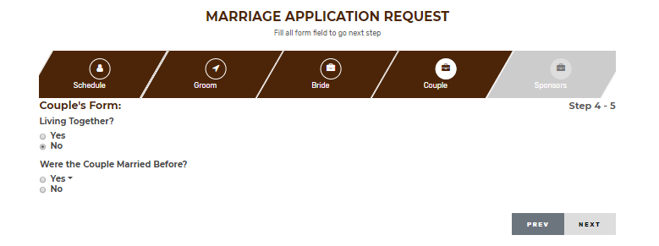

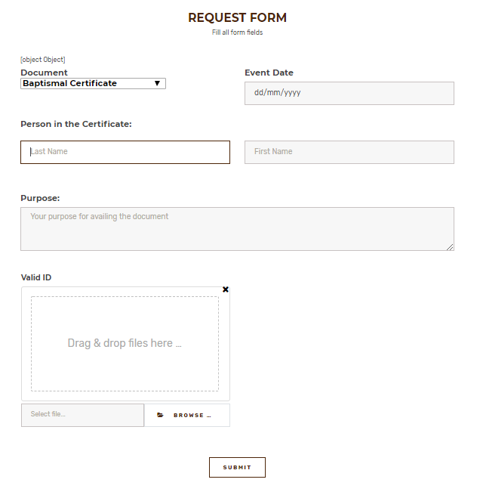

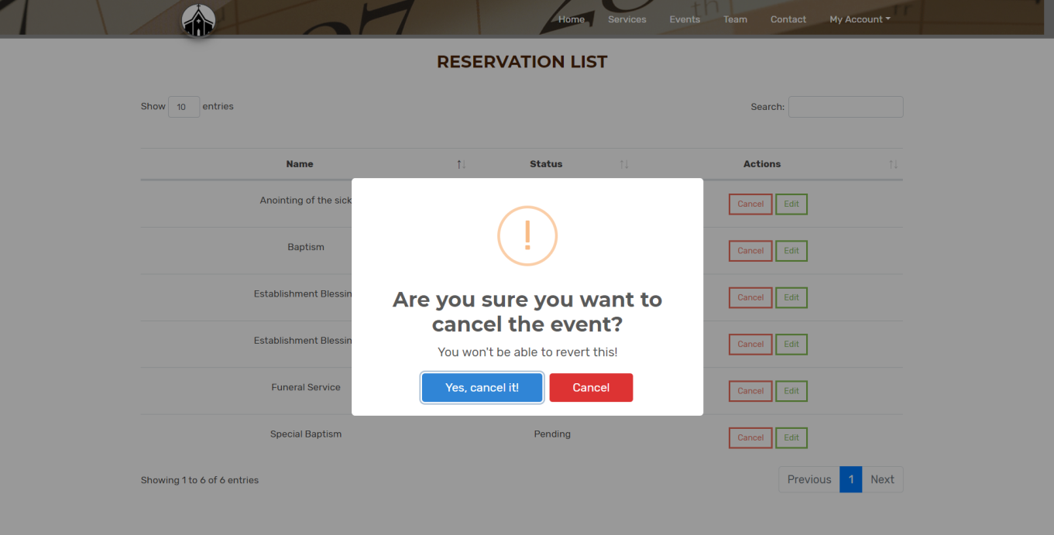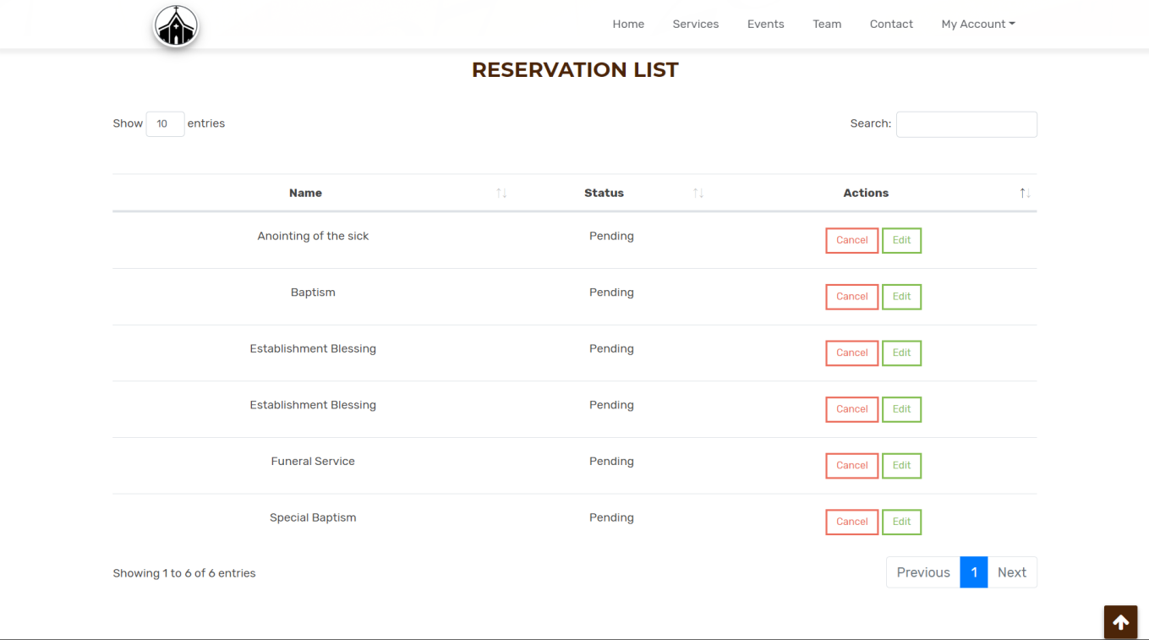

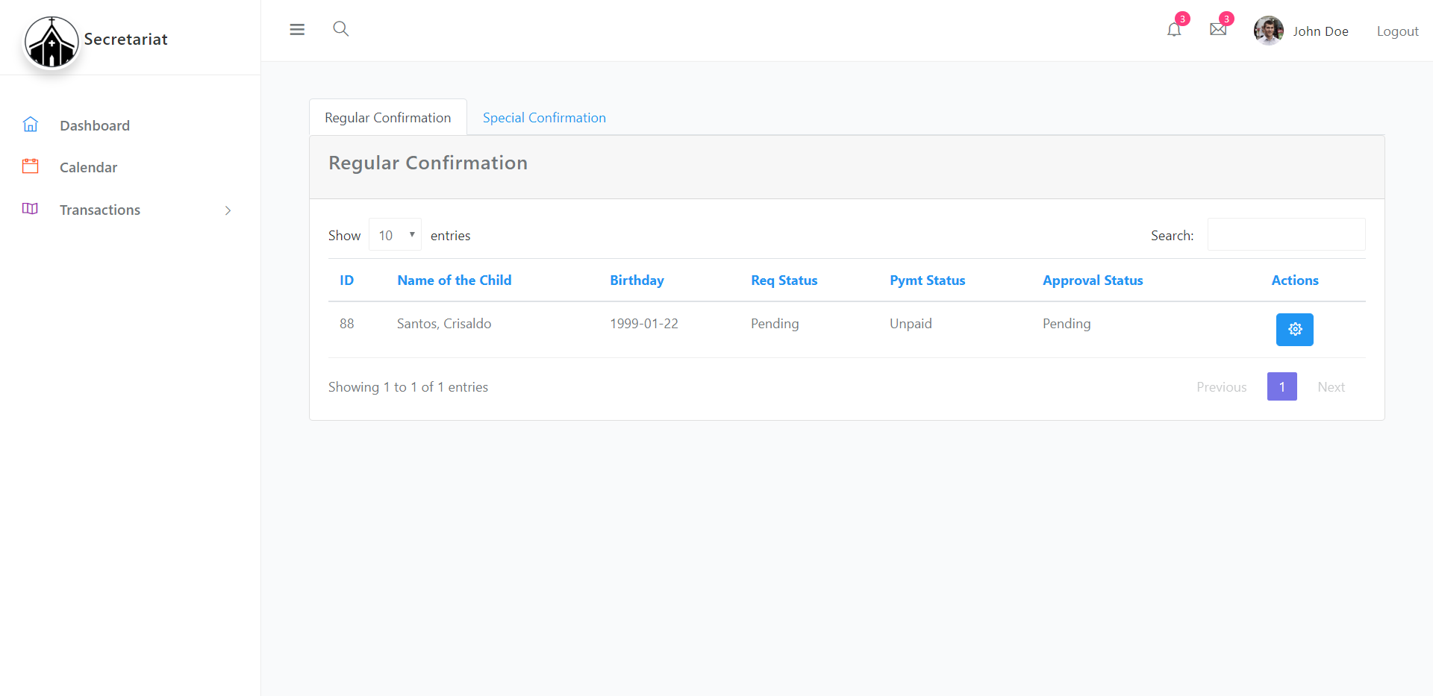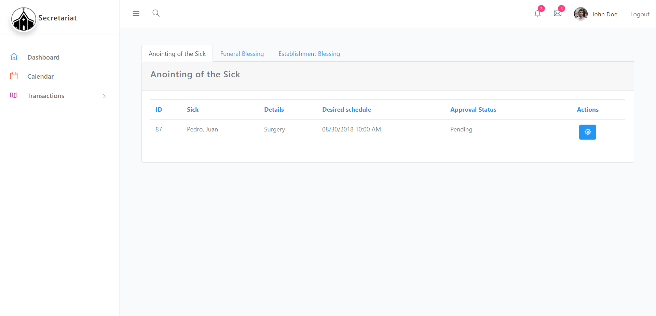

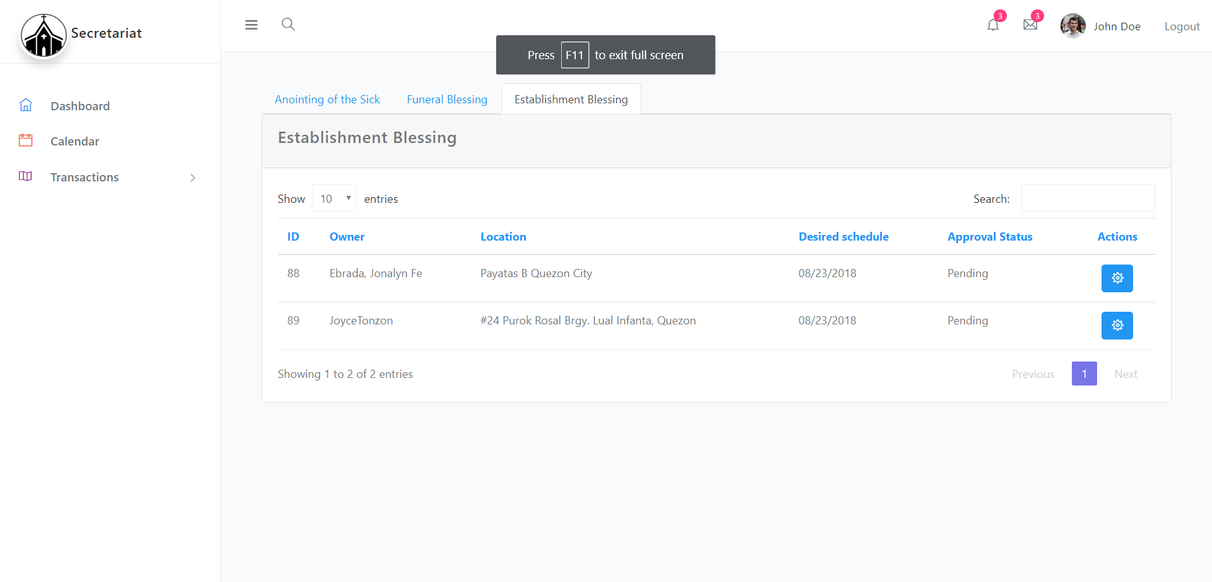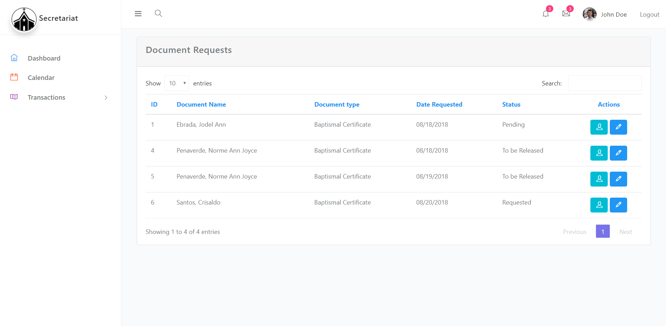

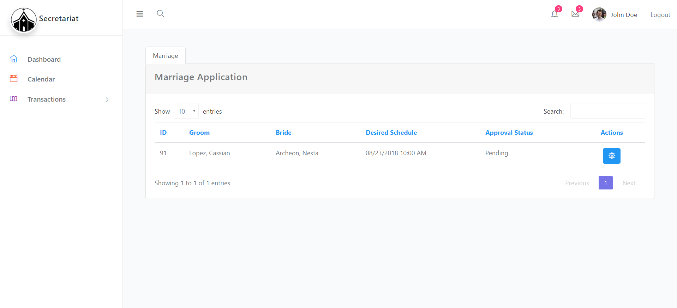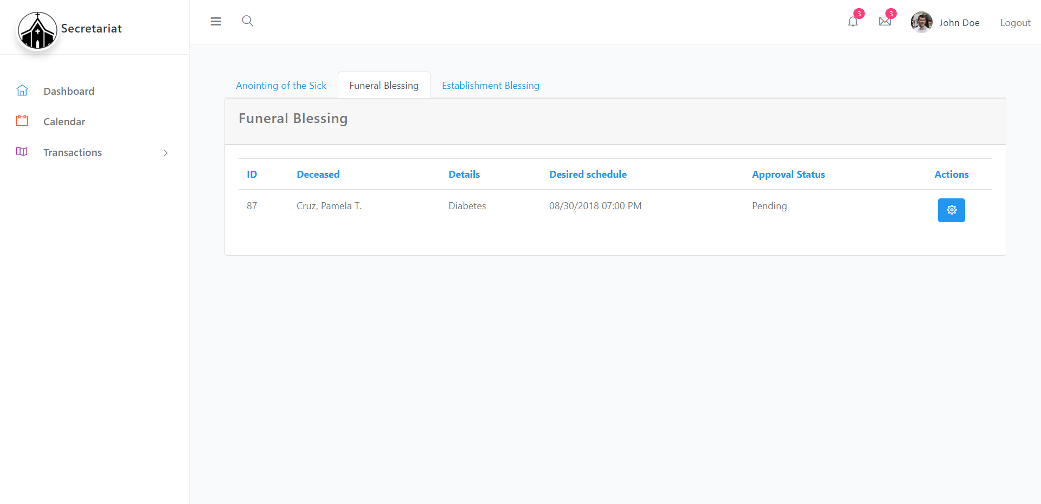

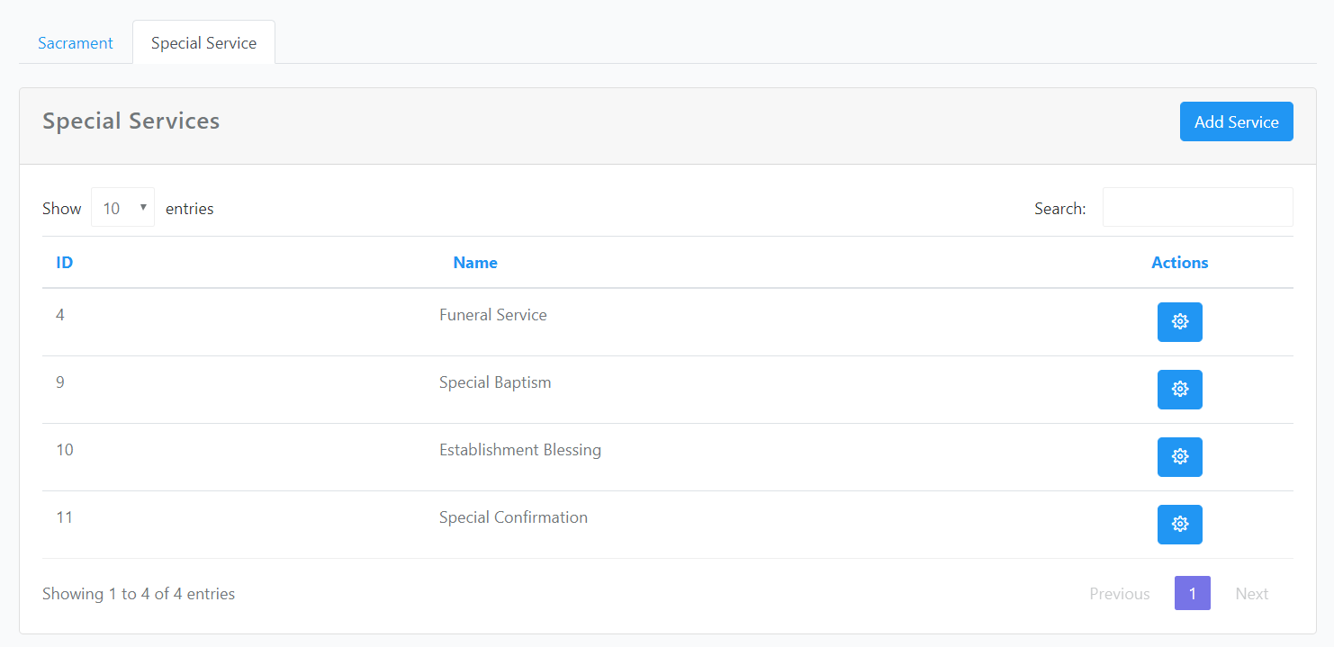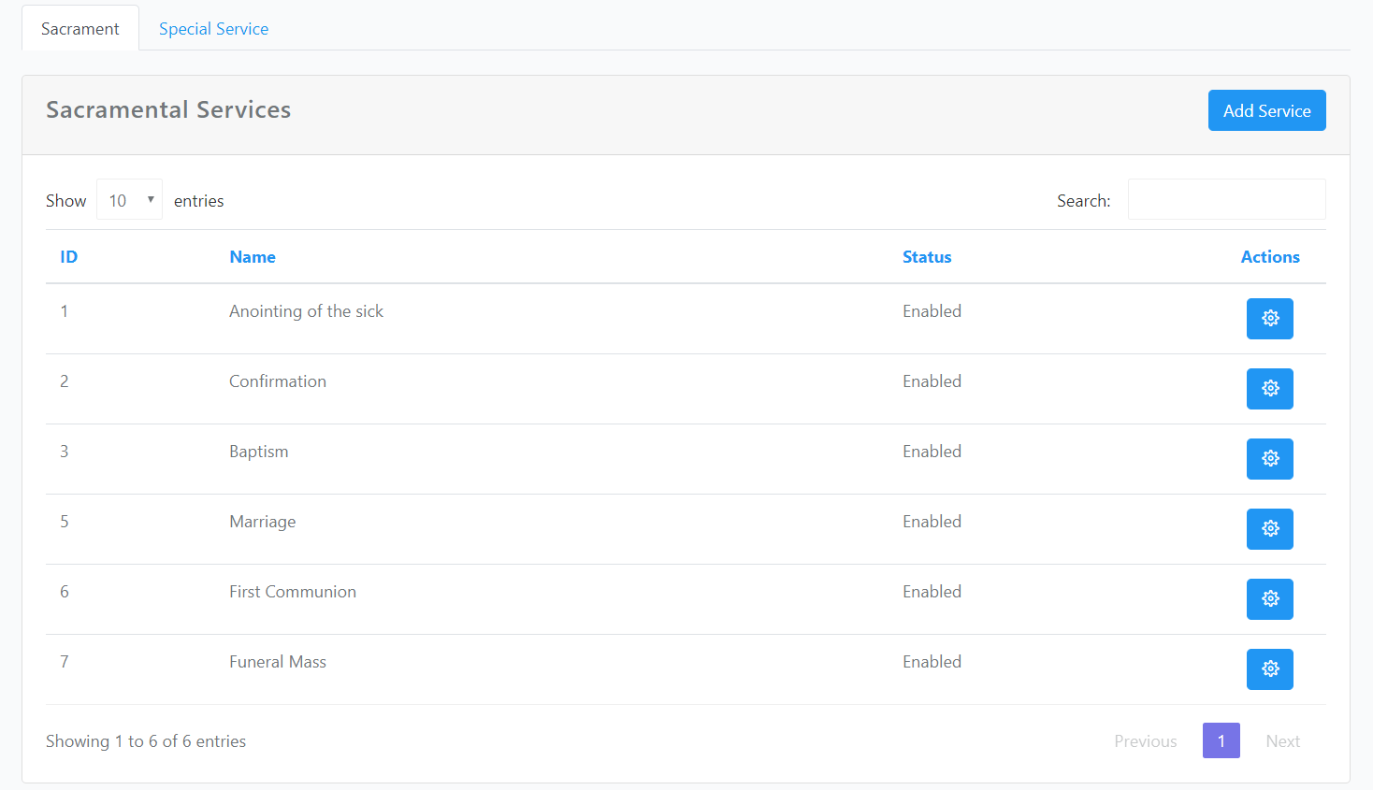

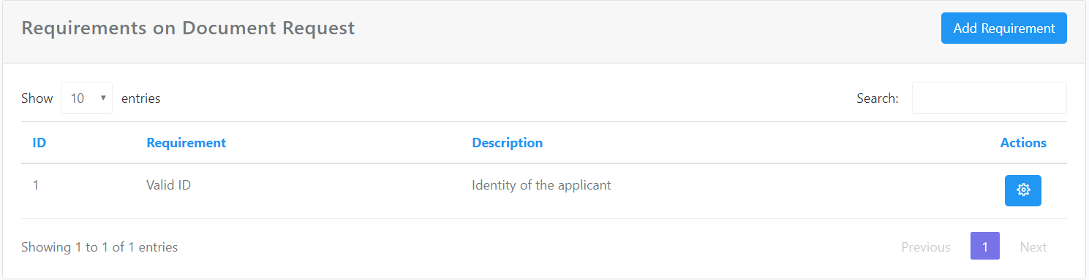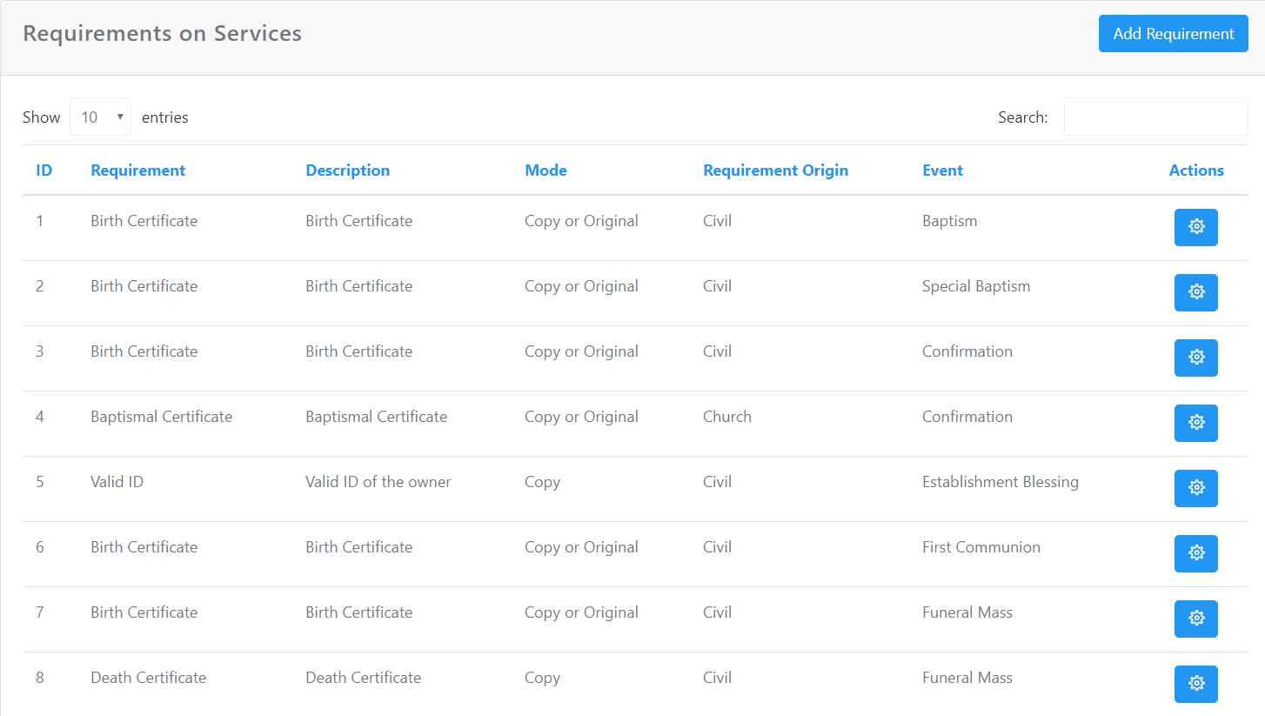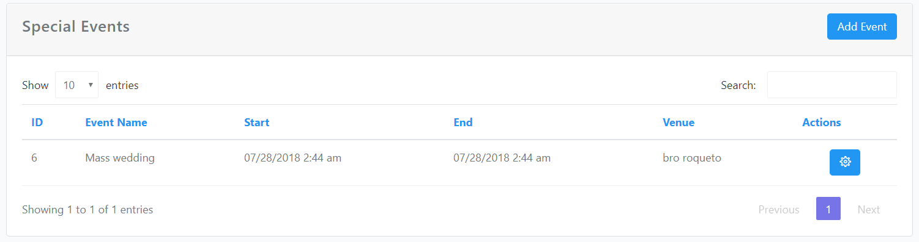

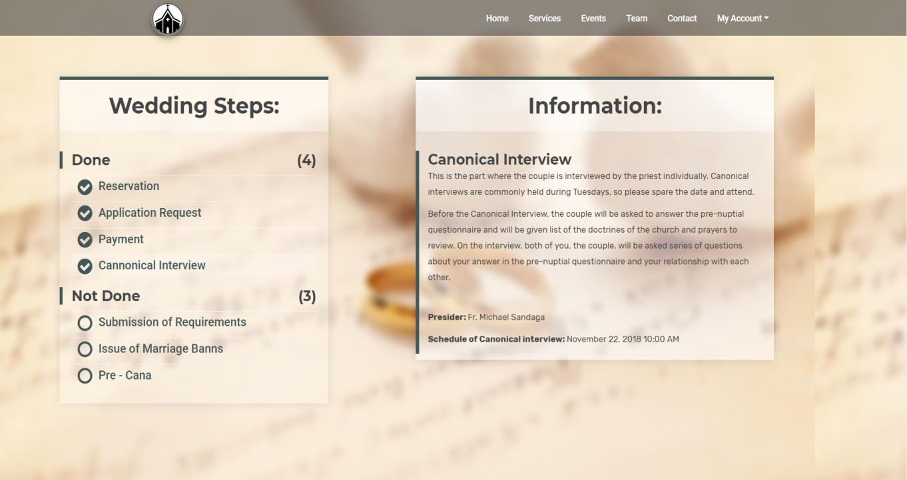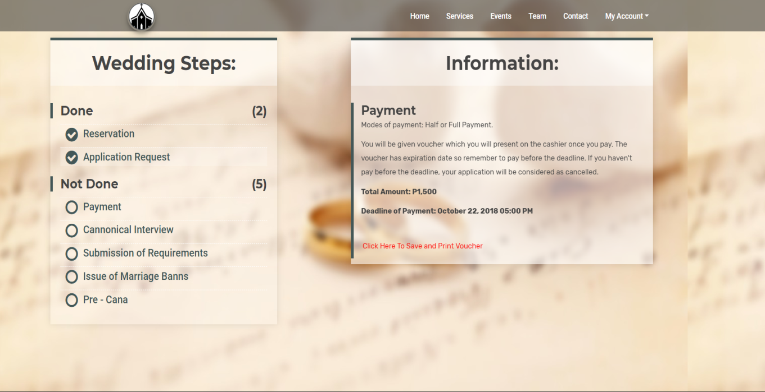

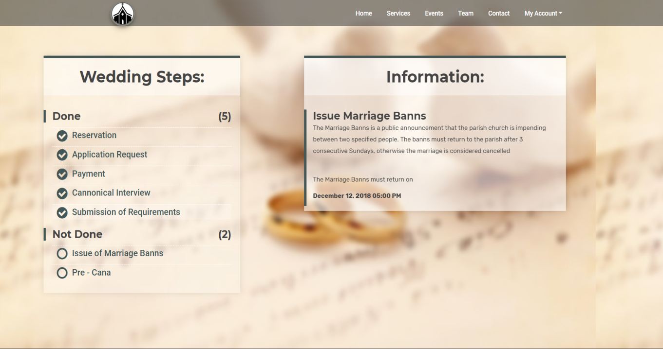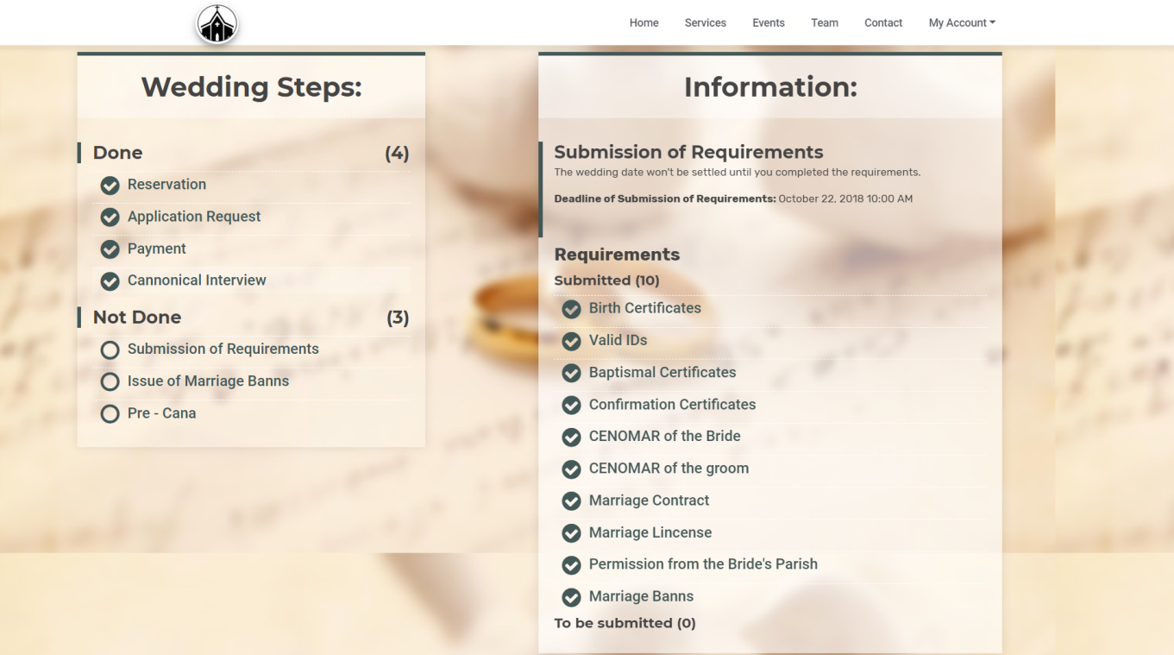

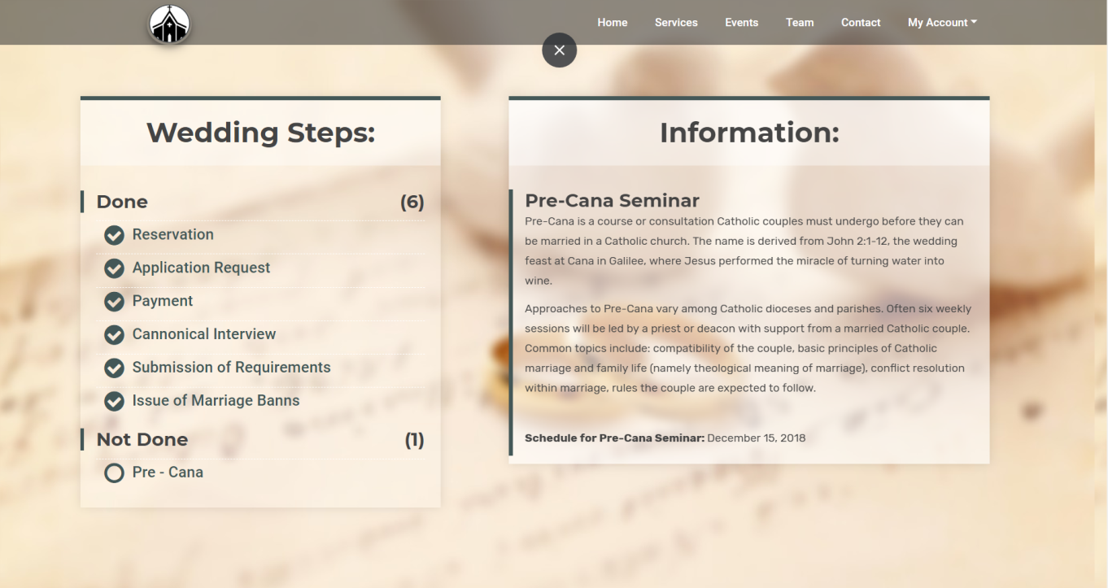

* + 1. Database Schema

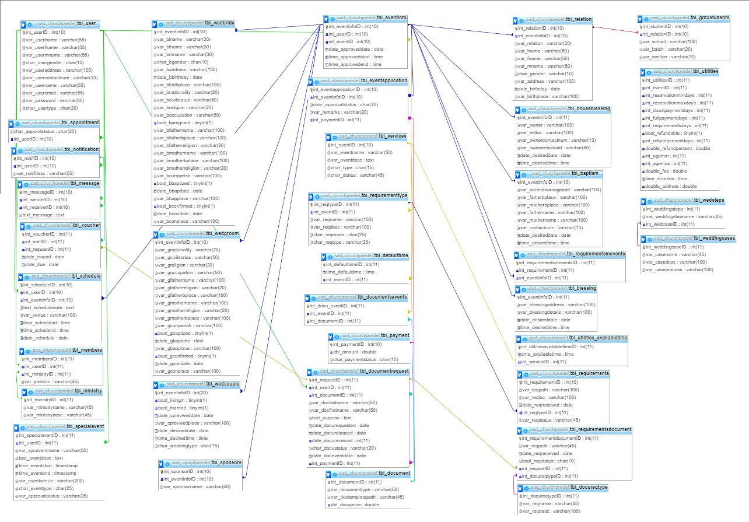

* + 1. Data Dictionary
  1. **Development Methodology** 
     1. 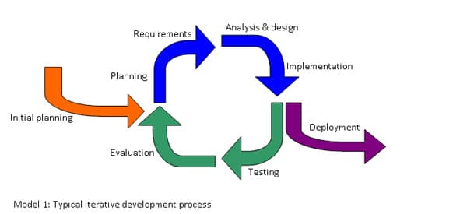Process Model

The iterative process model is used to develop a system through building its features in every component one by one. The developers chose to use this methodology to develop the system because they think it fits the proposed system. There are 4 phases in the iterative process model; the requirement, design, implementation and test phase, and review phase.

In the requirement phase, the developers identified and analyzed all the problems of the client. The information was gathered from the client, the Ina ng Lupang Pangako Parish, by conducting several interviews. They also asked for some documents which they can study to understand the processes more.

They studied their business process and listed the requirements and the business rules in the design phase. They proposed solutions to the problems of the client. They chose to improve the current process of the parish. They design the feature/component by applying their proposed process from the requirements and requirements gathered from the client.

The system was developed in the implementation and test phase. The project team distributed works to them. The system was tested first within the team. This served as their meeting to know if they meet all the requirements and the process is complete before they integrate it to the client.

For the last phase, the review phase, the client is expected to give their feedback about the system. The client might give some advices or request for some changes in the system which the project team may apply or not. If they will not apply the change request, they must explain well to the client so there would be no misunderstanding between them.

* + 1. Development Tools

The following are the development tools used by the team:

* Visual studio
* Node.js
* MySQL Workbench
* Helium and Adminator (Bootstrap templates)
* Github
* npm
* Adobe Photoshop